

Kinematic Analysis of 4R Robot using RoboAnalyzer and CPRog

Internship Project Report

Kaamya K

Robotics | Batch 12

Table of Contents

|  |  |
| --- | --- |
| Page no. | Title |
| 3 | Abstract |
| 3 | Introduction to 4R Manipulator |
| 4 | D-H Parameters |
| 5 | Kinematics |
| 7 | Introduction to RoboAnalyzer and CPRog |
| 7 | Kinematic Analysis using RoboAnalyzer |
| 18 | Kinematic Analysis using CPRog |
| 24 | Conclusion |

1. **Abstract**

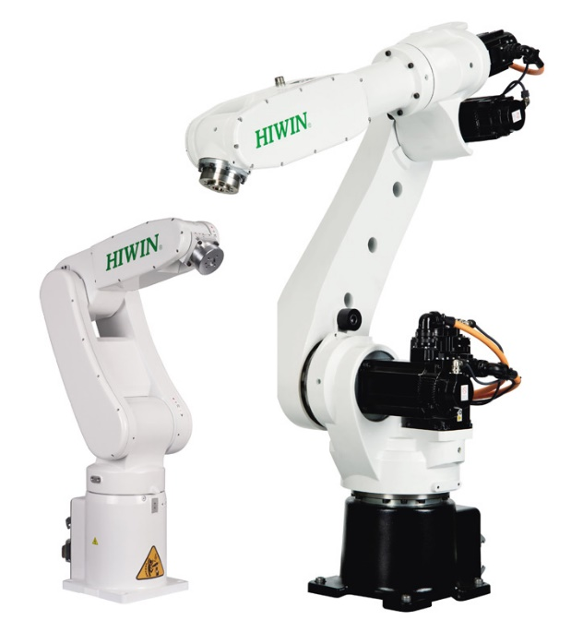A robot is an advanced device which is multifunctional and reprogrammable, designed to move parts, materials, tools, or any specialised devices through variable programmed motions to execute a range of tasks across various sectors.

Grippers of a manipulators are desired to move in a required fashion to do a specific task. The execution of a particular task requires the manipulator to follow a preplanned path, which is the larger problem of the motion or trajectory planning and motion control for the manipulator.

In present work, forward and inverse kinematics analysis of 4R Robot end effector is done for the given inputs using RoboAnalyzer and CPRog. Further, this project will describe the real-time working space simulation of robotic manipulator. The main advantage of using these softwares is that simulation tasks can be performed under exact conditions as they are in real time. In this type of robot simulation, point to point control of robot takes place.

Homogeneous transformation matrices were formed by using Denavit-Hartenberg parameters to obtain the forward kinematics of the robotic arm. An inverse kinematic solution has been used to attain the joint variables. Kinematic equations and analysis of the 4R robot manipulator are performed using Robo Analyzer and CPRog softwares.

1. **Introduction to 4R Robotic Manipulator**

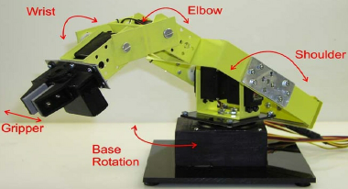A 4R robot consists of 4 rotational joints connected consecutively, whose behaviour is that of a deployable mechanism with wide workspace and small volume, when fully closed. It may be powered by a variety of means to execute required tasks, reducing human efforts.

The last axis is located near the base of the robot, and it provides the movement and the stability needed for the entire robotic arm to function correctly.

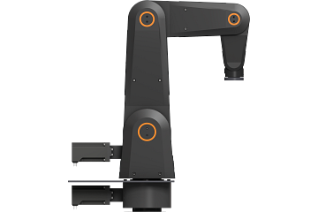This type of robot is used in palletizing, machine loading, pick and place, automated packaging, among many other roles. The design is a little complicated, but it gets more done in return.

An example of a 4-DoF robot may be presented with “igus [robolink® RL-DP-4”, which has the following specifications](https://www.igus.in/product/20232?articleid=84433):

• Payload up to 3.0 kg

• Up to 790 mm of reach

• Degrees of freedom: 4

• Speed: 7 picks/min.

• Min. service life: 1 million cycles

1. **DH Parameters**

The Denavit and Hartenberg parameters are used to study and analyse kinematics of robot movements, particularly at their end effectors. This is done by setting up coordinate frames for every joint and establishing a set of transformations that take place from one joint frame to the next (adjacent). The parameters are as follows:

1. *Joint Offset – ‘b’ / ‘d’ (m)*: Length of intersections of common normal on join axis (translation along the Zi-1 axis by di).
2. *Joint Angle – ‘θ’ (∘)*:Angle between orthogonal projections of the common normal to the plane normal to the joint axes (rotation about the Zi-1 axis by *θ* i).
3. *Link Length – ‘a’ (m)*: Measures as distance between common normal to the axis (translation along Xi axis – newly rotated axis).
4. *Twist Angle / Link Twist – ‘α’ (∘)*: Angle between orthogonal projections of the joint axes onto a plane normal to common normal (rotation about the Xi axis by αi).

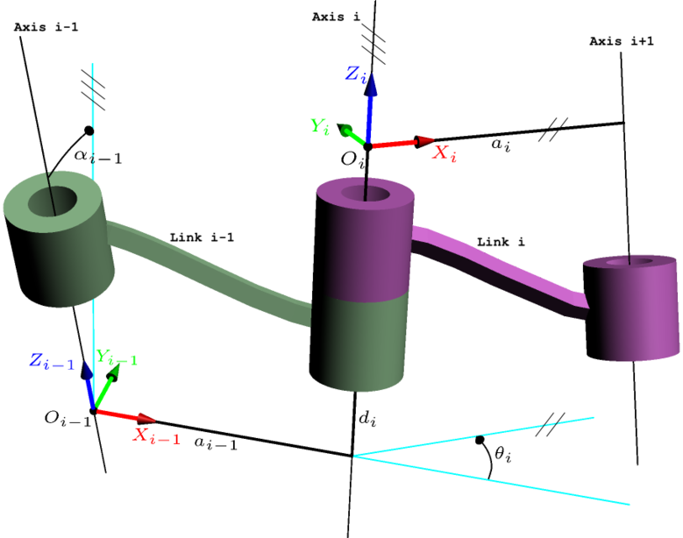

1. **Kinematics**

Robot kinematics studies the relationship between the dimensions and connectivity of kinematic chains and the position, velocity and acceleration of each of the links in the robotic system. A manipulator is composed of serial links which are affixed to each other’s revolute or prismatic joints from the base frame through the end effector.

A yellow robotic arm with black and white lines and symbols

https://www.researchgate.net/publication/279201859_Kinematics_Modeling_of_a_4-DOF_Robotic_Arm

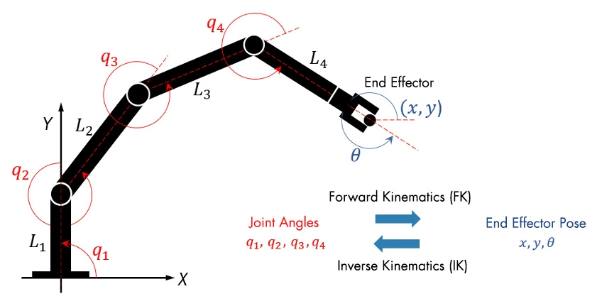

1. Forward Kinematics

Calculating the position and orientation of the end effector in terms of joint variable is called forward kinematics. To have forward kinematics for a robot mechanism in a systematic manner, one should use a suitable kinematics model.

Denavit-Hartenberg method that uses the four parameters is the most common method for describing robot kinematics. Using DH parameters, transformation matrix is obtained to find the position of the end effector.

1. Inverse Kinematics

Inverse kinematics problem of serial manipulators is needed for control of manipulators. Solving inverse kinematics is computationally expensive and generally takes a very long time in the real time control of manipulators. Tasks to be performed by a manipulator are in Cartesian space, whereas actuators work in joint space. Cartesian space orientation matrix and position vectors. However, joint space is represented by joint angles. The conversion of the position and orientation of a manipulator end effector from Cartesian space to joint space is the inverse kinematics problem.

Known parameters include link length and position of end effector, and its orientation. Using these values, it is possible to determine the joint parameters depending upon the joint type (**R**evolute-joint: joint angle and **P**rismatic-joint: joint offset).

1. **Introduction to RoboAnalyzer and CPRog**

* RoboAnalyzer:

RoboAnalyzer is a 3D model-based software that can be used to teach and learn the Robotics concepts. It is an evolving product developed in Mechatronics Lab, Department of Mechanical Engineering at IIT Delhi, New Delhi, India.

Mathematics involved in the study of robotics, such as forward and inverse kinematics. is initially difficult to understand, as is conveying the essence of mathematics of robotics. This is due to fact that the forward and inverse kinematics involve 3D transformations among other changing conditions. It is also to be noted that the industrial robots are represented using [Denavit and Hartenberg (DH) parameters](http://www.roboanalyzer.com/uploads/2/5/8/8/2588919/dhparams.pdf)  which are difficult to perceive and visualize in 3D. RoboAnalyzer helps eliminate the above mentioned difficulties.

* CPRog:

CPRog is a control and programming environment for robots. The 3D user interface allows a quick start into programming.

The simulation and programming environment CPRog offers the possibility to program robots with the help of an extensive 3D visualization.

This Windows software can be used as a complete controller in the training and maker area. For industrial use, the Linux-based real-time extension CPRog Core is interposed, to which the created programs are loaded. The big advantage of CPRog Core is the increased reliability in data transfer and significantly minimized latencies. Together CPRog and CPRog Core can be used optimally to control the robot.

In order to grip work pieces from a rectangular tray, one has to control the robot so that it moves a new position and then operates the gripper. The motions must be carried out multiple times for multiple items on the matrix. To simplify setting up such a motion, CPRog can handle loops and subprograms. For example, one could program two loops: one that increment the x and y of the target position and a second loop that controls the gripping motion.

1. **Kinematic Analysis of 4R Robot using Robo-Analyzer**

The 4R Robot is listed for selection in RoboAnalyzer software under 4-DoF, i.e., 4 degrees of freedom, indicating the number of independent movements that can be performed by the object. Each joint is typically associated with one DoF each. All the joints in the robot are of revolute type (R-joint).

Following are the default / standard DH parameters applied to the robot:

JVi, JVf indicate initial and final values of the variable DH parameter (depending on joint type).

|  |  |  |  |  |  |  |
| --- | --- | --- | --- | --- | --- | --- |
| Joint | (b)/(d)m | (θ)∘ | (a)m | (Α)∘ | JVi | JVf |
| J1 | 0.4 | Variable | 0.18 | 90 | 0 | 60 |
| J2 | 0.135 | Variable | 0.6 | 180 | 0 | 60 |
| J3 | 0.135 | Variable | 0.12 | -90 | 0 | 60 |
| J4 | 0.62 | Variable | 0 | 90 | 0 | 60 |

Changes are applied to the robot in terms of lengths and offsets of the robotic arm joints. The same maybe reflected in the parameters as follows, along with the modified model:

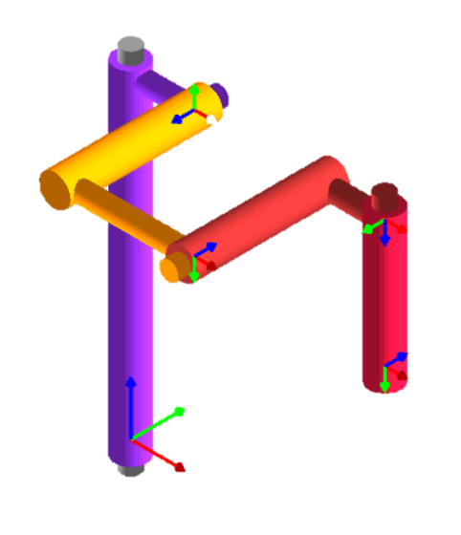[Modified Model]

|  |  |  |  |  |  |  |
| --- | --- | --- | --- | --- | --- | --- |
| Joint | (b)/(d)m | (θ)∘ | (a)m | (Α)∘ | JVi | JVf |
| J1 | 0.5 | Variable | 0.1 | 90 | 0 | 60 |
| J2 | 0.2 | Variable | 0.2 | 180 | 0 | 60 |
| J3 | 0.2 | Variable | 0.1 | -90 | 0 | 60 |
| J4 | 0.2 | Variable | 0 | 90 | 0 | 60 |

[DH Parameters may be visualised by selecting the joint and corresponding parameter. The same may also be done from base frame to end effector.]

End Effector configuration is obtained as follows with default values from the modified model:

$$\left[\begin{matrix}1 & 0 & 0 & 0.4 \\ 0 & 0 & 1 & 0 \\ 0 & -1 & 0 & 0.3 \\ 0 & 0 & 0 & 1\end{matrix}\right]$$

Applying forward kinematics (performing FKin operation under Analyses), the curved path generated by the end effector through the motion from initial to final values of DH parameters may be observed. With this motion, the change in DH parameters can be viewed by updating the end effector configuration, as follows:

The change in position of end effector post finalisation of all the variable parameters’ values, can be viewed as follows: [Top view, Front view, Right view and Isometric view]

|  |  |
| --- | --- |
|  |  |
|  |  |

Following are the various transformations that take place in the variable parameter of the 4R manipulator, i.e., Joint Angle:

1. Joint-1

1. Joint-2

1. Joint-3

1. Joint-4

The Robo Analyzer does not have the 4R Robotic Arm for performing inverse kinematic operations. However, assuming the case of existence of the model in the software, following procedure may be followed. Supposing we are aware of the current end effector configuration, joint variables may be derived through inverse kinematics. Applying the Ikin operation, the default values generally coinciding with the initial DH parameter values, and the end effector position as obtained from initial end effector configuration matrix.

The input data in this table is replaced with that obtained from the end effector position (through forward kinematics analysis performed previously). Hence, we have the following inputs for end effector position and orientation matrix.

**Results:**

Following are the changes obtained in various joints and links of the 4R Robot, visualised in form of a graph (upon varying the parameters from initial to final values – Forward Kinematics). Identical values may be obtained for joint parameters during inverse kinematic analyses via algebraic equations.

Links: The graphs consist of the parameters EndX(m), EndY(m) and EndZ(m). Each of these parameters denote the variation in movement of the joint link along the axes X, Y and Z. They are represented in the graphical forms for the joint links as follows:

Joint Parameters:

The joint-graphs consist of the parameters Joint Value, Joint Velocity, Joint Acceleration and Force/Torque. As suggested by their names, each of these parameters denote the variation in positioning and speeds of the arm-joints in the workspace for the sample duration. Force / Torque parameters are available in dynamic simulation (IDyn data), not used for current task. The parameters are represented in the graphical forms as follows:

1. **Kinematic Analysis of 4R Robot using CPRog**

Coding in CPRog is extremely easy and can be executed in any one of the following motion types: Joint, Base and Tool. However, this report will only be using Joint motion type for the project.

There are two ways of manipulating the robot’s movements:

1. By changing the values by selecting + or – for the joints, under Jogging.
2. Write a code by defining the measurement of each axis.

These codes can then be saved on the working desktops and used when and as required. For playing these codes and observing the movement of the robotic manipulator, the settings may be changed in Motion > Program Execution > Replay Mode. In Replay Mode, there are three types of movements: Single, Repeat and Step. This project has been executed by writing a code and using Step Mode.

The model used for execution of the same is: Robolink RL-DCi-4S-M

* Payload up to 1 kg
* Reach up to 510 mm
* DOF: 4
* Speed: 6 picks / min
* Minimum service life: one million cycles

Typically, this type of articulated arm robot is used at cycle times of > 7 s. As standard, the robot is available in black color. The robolink robotic components are largely made of tribologically optimized plastics. This enables high cost savings while ensuring a long service life and freedom from maintenance. The model maybe viewed in the CPRog simulation workspace as follows:

To import the model in CPRog, the igus Robot Control program is utilized. In the data, RL-DCi-4SM model is stored in the robolink folder under projects and robots. The project folder consists of .prj file of the model. The corresponding files are copied to “projects” and “robots” folder in the CPRog data folder.

Following the minimum and maximum values of the variable joint parameters (in current case, the joint angles):

|  |  |
| --- | --- |
| Minimum Values (deg / ○) |  |
| A1: -140.0  A2: -45.0  A3: -85.0  A4: -29.8 |
| Maximum Values (deg / ○) |  |
| A1: 140.0  A2: 89.9  A3: 55.1  A4: 120.0 |

Following is the initial setup and positioning of the model:

With these initial coordinates, the program below is then loaded onto the model. This option may be viewed under the “Motion” tab, navigating to the options for “Current Program”.

The program is edited by tuning the axes’ values for each iteration / step. This project makes use of Joint motion for this task.

A total of 5 iterations are added, which may be modied to repeat continuously or execute a single time depending on the context of usage.

The initial iteration is marked as 0, denoting the initiation of the process.

Undermentioned is the program that is saved and loaded onto the model:

The execution / simulation of the same is observed under Step Replay mode. We get the resulting positions:

1. Command-1

1. Command-2

1. Command-3:

1. Command-4:

1. Command-5:

1. **Conclusion**

Forward and inverse kinematics for 4R Robotics manipulator is determined by using RoboAnalyzer and CPRog software. The values have been cross-examined and determined to match the corresponding position and orientation of each joint. It is very complicated to find velocity, force, and torque values in theoretical approach. By using RoboAnalyzer, it is easy to find velocity, acceleration graphs and their values’ corresponding links and joints, and simulation of robot end effector arm can be performed. It has proven, through the project, to help in forward and inverse kinematic analyses and their usage in prediction of end effector positioning and joint variables respectively. The same may be simulated in real-time using the CPRog software to monitor the robot’s movements and performance and verify the task execution accuracy.

Modelling of 4R igus robot is done using RoboAnalyzer. The program is written in CPRog.

Throughout the course and training of this project, focus has been emphasized on different types of robots based on links and joints, Forward and Inverse Kinematics, and their usage in prediction of end effector and the joint variables, respectively. Usage of Homogenous Matrices in description of translation, rotation or both in a matrix and the 4 D-H parameters: Joint angle, Link offset, Link length and Link twist has been highlighted. The project enables us to use the RoboAnalyzer software for analyzing and checking designs for different robot types. The same may be relayed for using CPRog, a simulation and programming environment, to simulate(and code) robots and observe their movements virtually.

[End of Document]